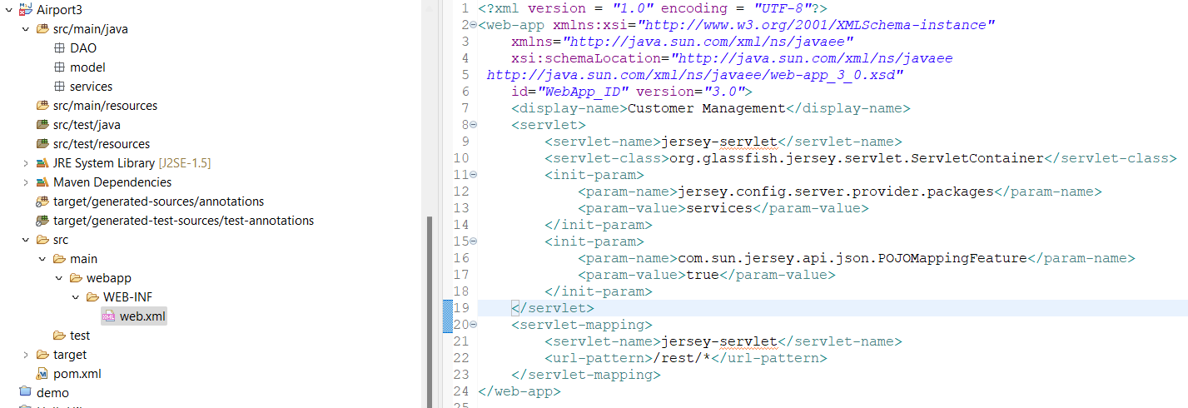

ดูที่ hibernate source และเพิ่ม

ไปที่ model เพิ่ม JsonIgnore ที่เป็น foreign key

ตัวอย่าง query Booking

BookingService

GET

POST

PUT

DELETE

ตัวอย่าง query User

POST

PUT

DELETE

